USER GUIDES FOR EXCHANGE SYSTEM

- USER REGISTRATION
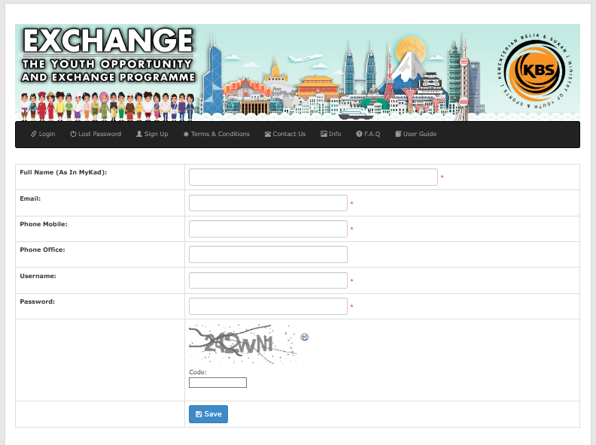
  - For the first time user, Click Sign Up and fill in the information requested as shown and Click Save.

  - Registered users will receive a notification on the registered email.
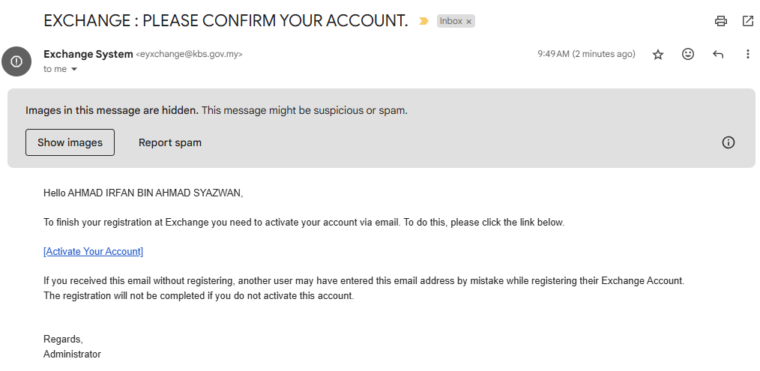
  - Click on the link Activate Your Account to activate your account for registration activation.
- LOGIN
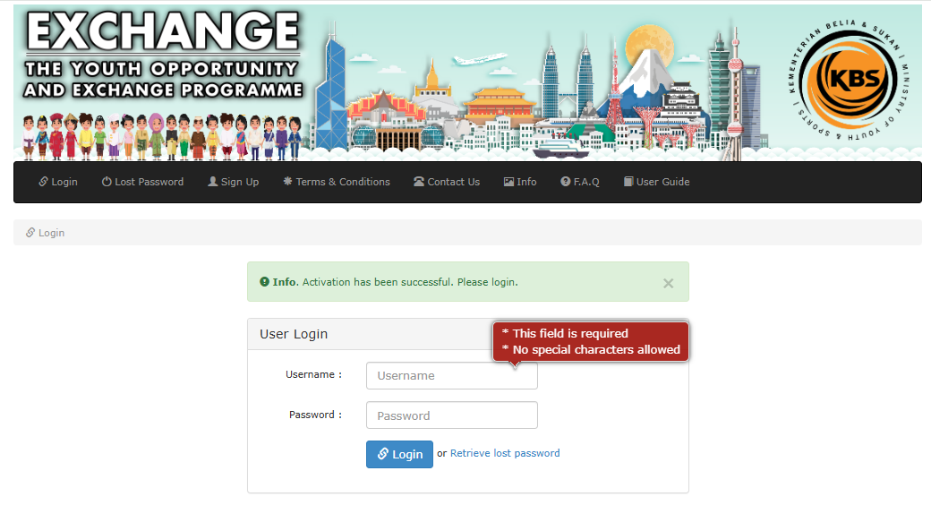
  - Fill in the Username and Password. Click on the Login button.

- TERMS AND CONDITIONS
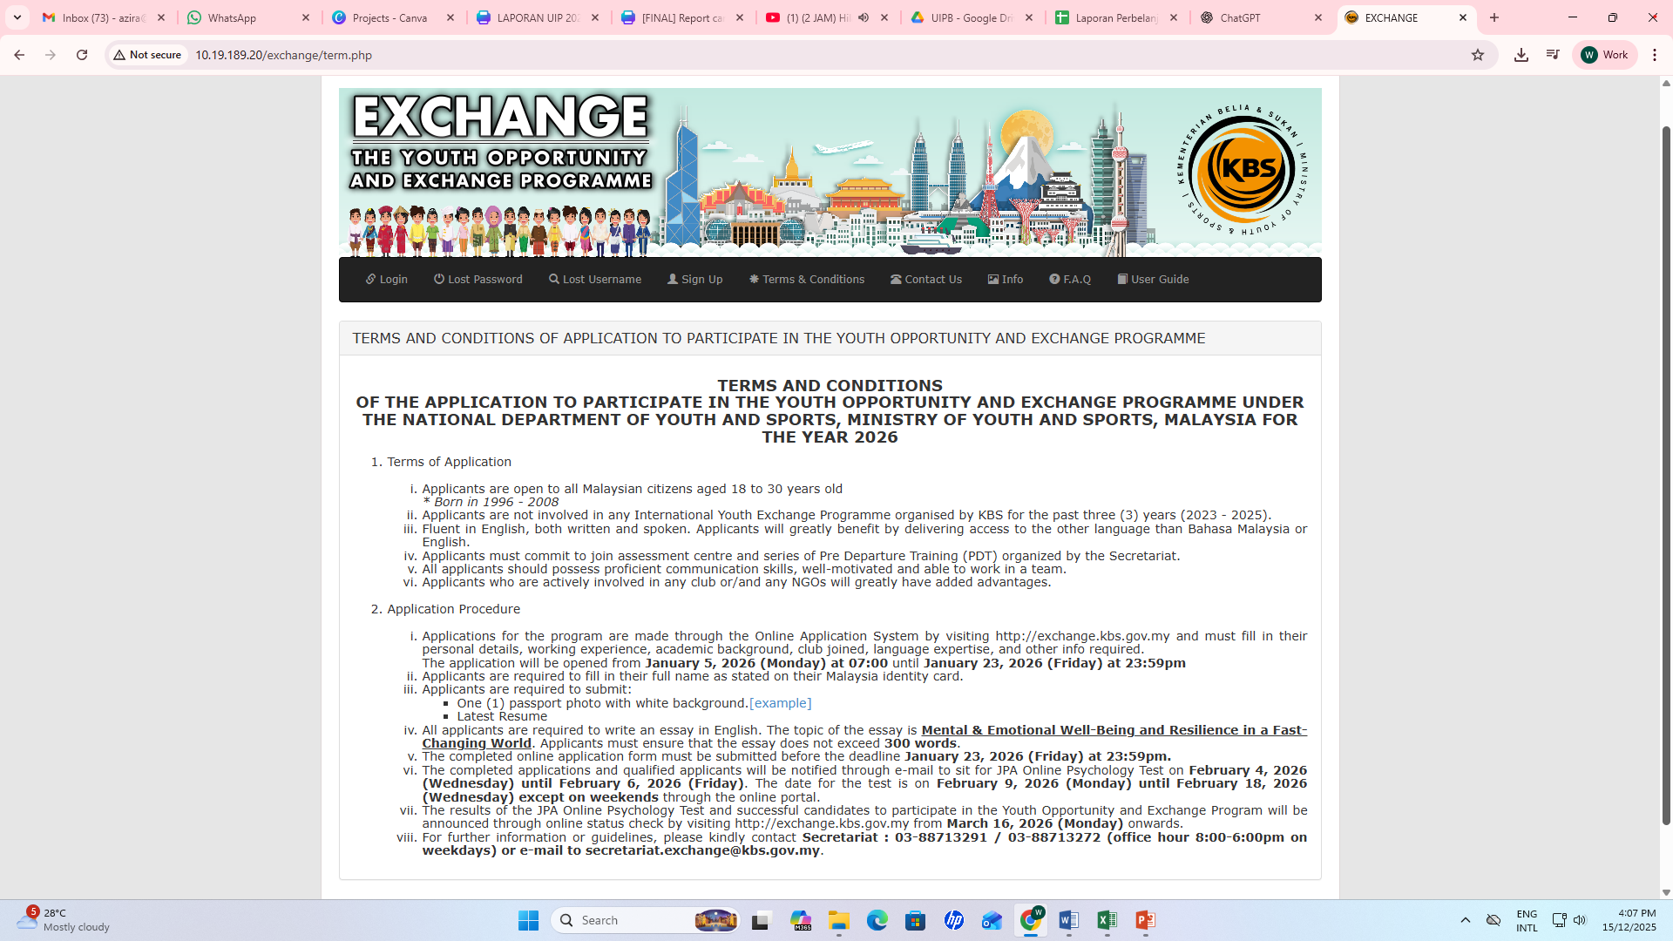
- Applicant are required to read Terms and Conditions.

- APPLICATION FORM


- Click on Application Form. Fill in the applicant's Programme details as designated. Note: Applicant must upload his/her formal photo as required. Example :
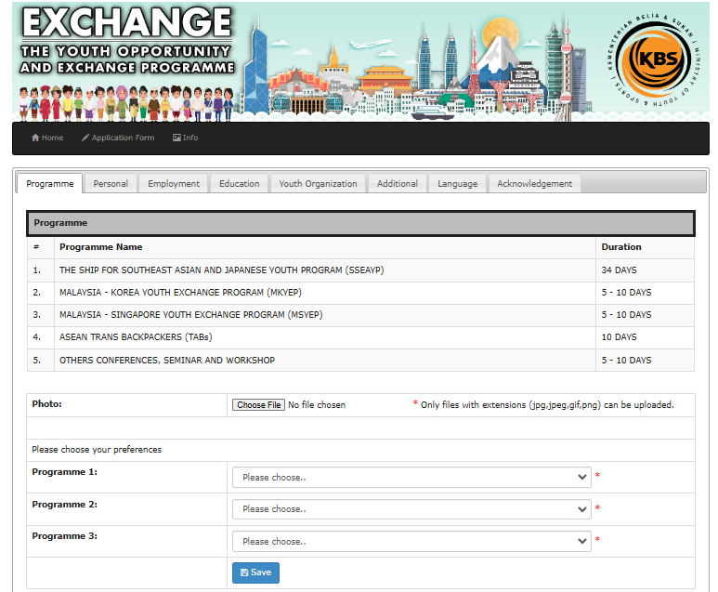

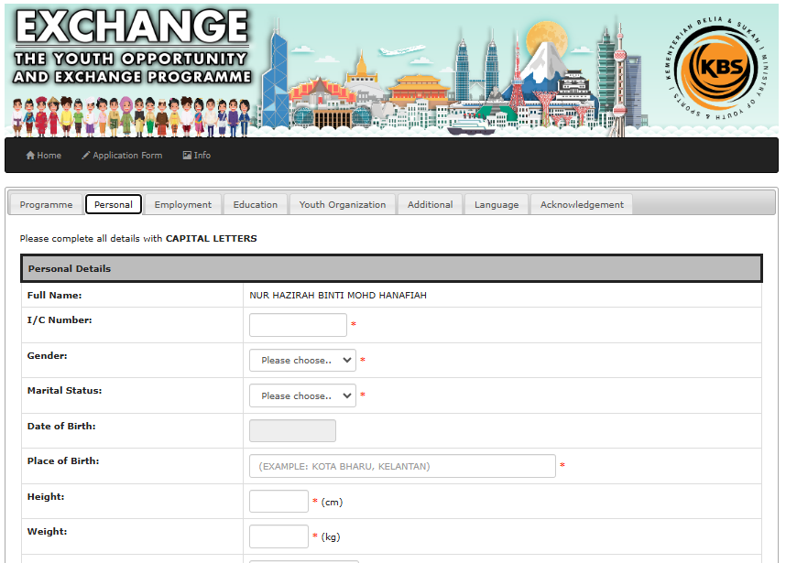
- Fill in the applicant’s Personal Information and Click on Save button

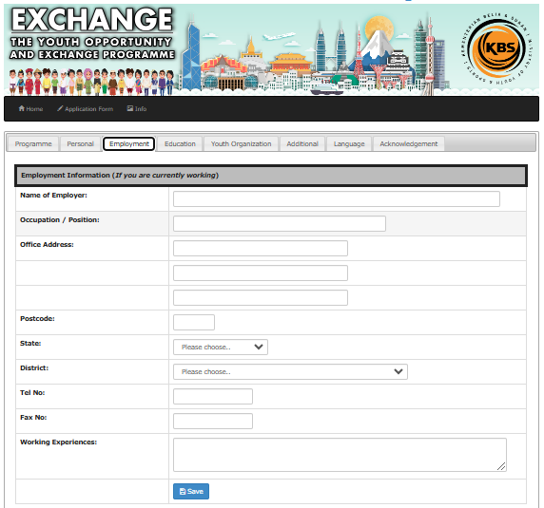
- If the applicant is currently working, fill in the applicant’s Employment information and Click on Save.
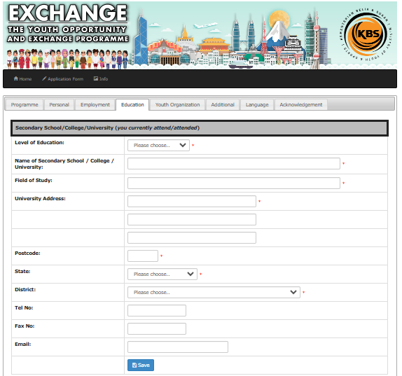
- Fill in the applicant’s Education information as required.

- If the applicant is registered with any Youth Organization or NGOs, fill in the applicant’s Youth Organization information and Click on Save.
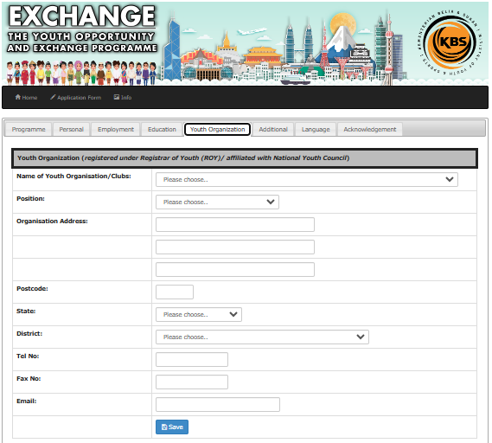

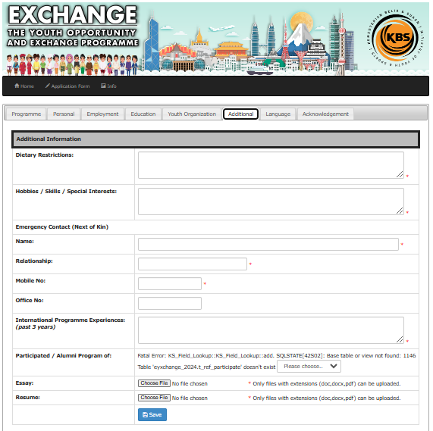
- Fill in the applicant’s Addition information as required. Note: Applicants must upload their Essay and Resume. Essay must be written in English and should not exceed 300 words.

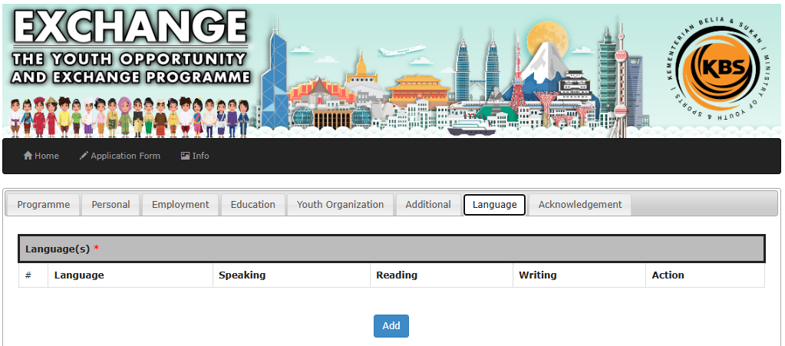
- Fill in the applicant’s Language information as required.

- Click the box of Acknowledgments and Click Submit button.
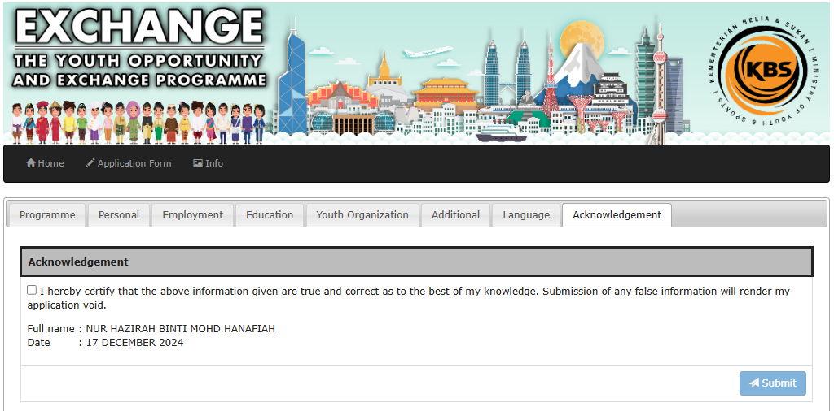

- FORGOTTEN OR RESETTING YOUR PASSWORD
  - Click on the Retrieve Lost Password
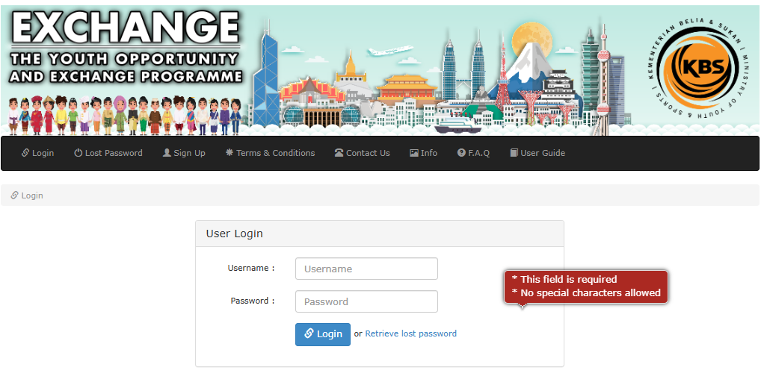

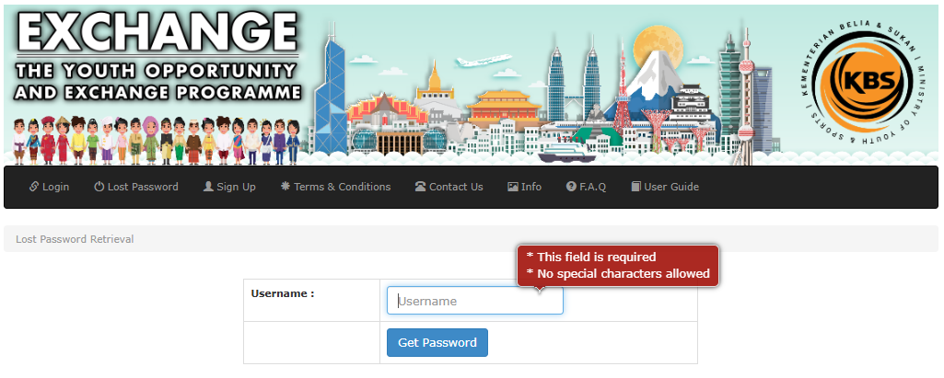
  - Enter the username on the account as required and Click Get Password button.

  - A user will receive a notification on the registered email

  - Check your email notification for a password reset email and Click on the link Retrieve Your Password.
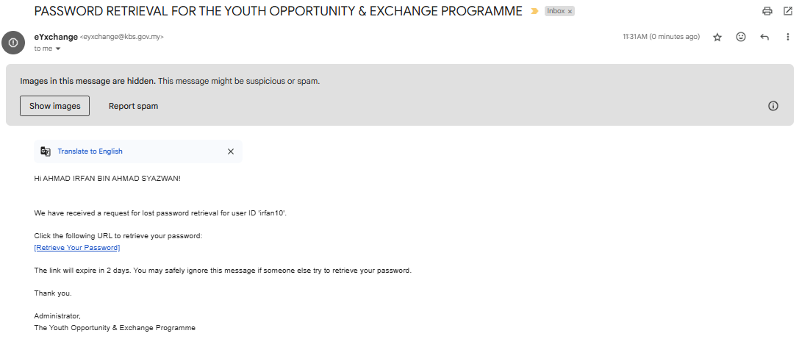

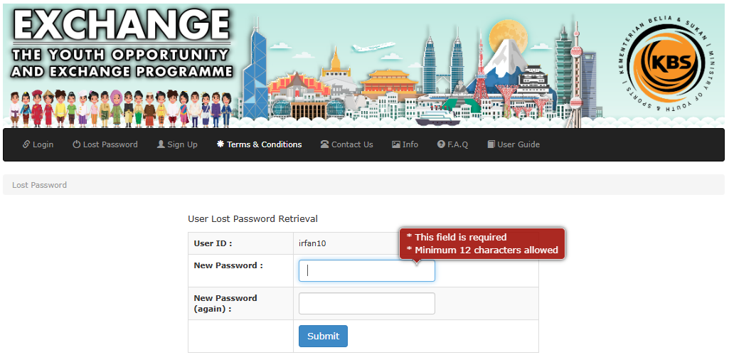
  - Fill in the New Password and New Password (again) as required and Click Submit.

